Types of Machine Learning
1. Supervised Learning
- Humans give correct answers (labels).
- Model learns from labeled data.
- Example: Email spam detection.
2. Unsupervised Learning
- No labels.
- Computer finds patterns by itself.
- Example: Customer grouping.
3. Reinforcement Learning
- No labeled data.
- Learns from rewards and penalties.
Focuses on decision making over time.

What is Reinforcement Learning (RL)?
Definition (Simple)
Reinforcement Learning is a machine learning method where:
- An agent learns
- By interacting with an environment
- And receiving feedback (reward or penalty)
- To achieve a goal
It is a feedback-based learning approach.

How RL Works (Basic Idea)
- Agent looks at the environment.
- Agent takes an action.
- Environment gives feedback:
  - Positive reward → good action
  - Negative reward (penalty) → bad action
- Agent learns from this feedback.
- Over time, agent improves decisions.
The agent learns from experience, not from labeled data.

Goal of Reinforcement Learning
The goal is: To achieve the best possible long-term result.
Chess Game
- Goal: Win the game.
- If move is good → reward.
- If move is bad → penalty.
- Agent learns which moves increase chances of winning.

Agent Example (Fire and Water)
Your example:
There are 2 choices:
- Fire → Wrong choice → -50 points
- Water → Correct choice → +50 points
So:
- If agent chooses fire → gets negative feedback.
- If agent chooses water → gets positive feedback.
After many tries:
- Agent learns water is better.
- Stops choosing fire.
That is learning through reward.

Feedback Mechanism
Whenever an action is taken:
Action → Environment → Feedback → Agent learns
For each:
- Good action → Positive reward
- Bad action → Negative reward
This is how behavior improves over time.

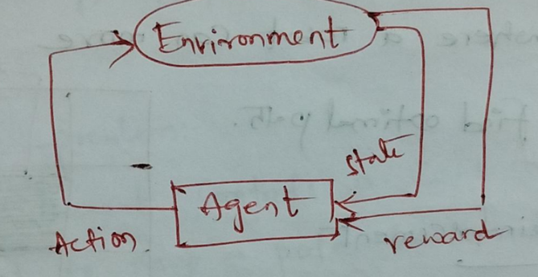
RL System Diagram Explanation Environment ↔ Agent
Detailed flow:
- Agent observes state
- Agent takes action
- Environment gives:
  - New state
Reward
Loop continues again and again.

Where RL is Used
RL is used when:
- Decision making is sequential
- Goal is long-term
Examples:
- Game playing
- Robotics
- Self-driving cars
- Recommendation systems

Types of Reinforcement
Positive Reinforcement
Definition:
Behavior increases because of positive reward.
Effects:
- Increases strength of behavior
- Increases frequency of behavior
- Encourages repeating similar action
Example:
Dog sits → gets biscuit → sits again next time.

Negative Reinforcement
Definition:
Removing something bad to encourage behavior.
From your notes:
- Negative rewards act as deterrent.
- Decreases unwanted behavior.
Example:
Touch hot stove → pain → avoid stove next time.

Important Terms in RL
Agent
An entity that:
- Takes actions
- Learns
- Makes decisions
Examples:
- Robot
- Game player
- Car
- Software recommender

Environment
Everything around the agent.
It:
- Responds to agent’s actions
- Gives new state
- Gives reward

Action
What agent does.
Examples:
- Move left
- Move right
- Pick object
- Accelerate car

State
Current situation of environment.
Example:
In chess → current board position.
In robot → current location.

Reward
Feedback from environment.
- Positive reward → good
- Negative reward → bad
Reward helps agent evaluate action quality.

Policy
Policy is a strategy used by the agent to decide action based on current state.
Simple meaning:
Policy = Rule that tells
“What action to take in this situation?”
It can be:
- Simple rule
- Or complex mathematical function

Bellman Equation
It is used to:
- Break big problems into smaller subproblems.
- Calculate value of a state.
- Help find optimal policy.
Simple idea:
Value of current state = Immediate reward + Future reward (expected)
It helps agent think about long-term reward.

Getting Lost in RL
"Getting lost" means: Agent fails to find optimal solution because:
- Poor exploration
- Insufficient training
- Gets stuck in suboptimal strategy
Let’s explain each example.

- Cartpole Problem
Goal: Keep a pole balanced on moving cart.
Problem: If agent doesn’t explore enough,
It may:
- Learn wrong balancing technique
- Pole falls
So it gets stuck in bad policy.

- Mountain Car Problem
Goal: Drive car up steep hill.
Problem: Car engine not strong enough.
Correct strategy:
- First go backward
- Gain momentum
- Then go forward
If agent keeps trying direct uphill:
It fails repeatedly.
This is getting stuck.

- Robot Navigation
Goal: Move from start to goal avoiding obstacles.
Problem:
Agent may:
- Hit obstacles repeatedly
- Move in loops
- Fail to reach goal
Due to poor exploration.

- Game Playing (Chess, Go)
Goal: Win the game
Problem:
Agent:
- Makes poor moves
- Doesn’t understand dynamic strategy
- Loses game
Because:
- Not enough training
- Poor exploration

- Recommendation System
Goal: Recommend best products.
Problem:
Agent may:
- Recommend irrelevant items
- Repeat same suggestions
- Fail to improve user satisfaction
Again due to poor learning.

- Grid Game Example
In your drawing:
There are:
- Goal cell
- Danger cell
- Blocked cells
Agent must:
- Find optimal path
- Avoid danger
- Avoid blocked areas
Each move gives reward or penalty.
Agent learns best path over time.

- Maze Game Example
Maze may have:
- Danger spot
- Safe path
- Goal
Agent:
- Explores maze
- Learns which path gives highest reward

Sampling
Definition:
Sampling = Taking small subset of data
To estimate characteristics of whole population.
In RL:
- Agent doesn’t try all possibilities.
- It samples experiences.
- Learns from sampled experience.
This reduces computation.

MCMC
(Markov chain Monte Carlo)
Why MCMC is Needed?
Sometimes we want to sample from a complex probability distribution:
- High dimensional
- Cannot compute integral directly
- Cannot sample directly
Example:
Posterior distribution in Bayesian inference.
In high dimensions:
Direct sampling becomes computationally infeasible.
So we approximate using MCMC.

What is MCMC?
MCMC = Markov Chain Monte Carlo
It combines two ideas:
- Markov Chain
- Monte Carlo Sampling

Markov Chain (First Concept)
Definition:
A sequence of random variables where:
$$P(X_{n+1}∣X_{n},X_{n-1},...,X_{0})=P(X_{n+1}∣X_{n})$$
Meaning:
The next state depends only on the current state.
This is called Markov Property (Memoryless property).

Importance in MCMC:
We design the Markov chain such that: Its stationary distribution = Target distribution

Stationary Distribution
A distribution π(x) is stationary if:
After many transitions, the distribution does not change.
(If chain reaches π(x), it stays there. That is our goal.)

Monte Carlo Concept
Monte Carlo means: Using random sampling to approximate quantities.
Example: To estimate area under a curve:
- Randomly generate points
- Count points under curve
- Estimate area
In MCMC:
We generate samples from target distribution and estimate:
$$E[f(x)]≈\frac{1}{N}∑f(x_{i})$$
Convergence
Over time: The Markov chain samples will:
Converge to the target distribution.
Initially: Samples are biased.
After many iterations: They represent the true distribution.
This is why we discard initial samples (Burn-in period).

Proposal Distribution (Very Important)
Denoted as:
$$q(x^{'}∣x)$$
Meaning: Probability of proposing new state x′ given current state x.
Purpose:
It suggests candidate points.
Then we decide:
- Accept?
- Reject?
Without proposal distribution, chain cannot move.

Common MCMC Algorithms are : Metropolis-Hastings, Gibbs, and Hamiltonian Monte carlo Approaches

Types of Proposal Distributions
Independent Proposal
$$q(x^{'}∣x)=q(x^{'})$$
Does not depend on current state.

Symmetric Proposal
$$q(x→y)=q(y→x)$$
Forward and backward probability same.
Example: Gaussian centered at current state.

Asymmetric Proposal
$$q(x→y)≠q(y→x)$$
Then acceptance probability must adjust.

Gaussian (Normal) Proposal
Very common choice: $x^{'}=x+ϵ$
$$ϵ∼N(0,σ^{2})$$
Meaning:
Small random step around current state.
Random Walk Proposal
Special case of Gaussian proposal:
$$x^{'}=x+Δ$$
Small step from current state.
Used in:
Random Walk Metropolis.
Multivariate Proposal
If multiple parameters:
$$x∼N(μ,Σ)$$
Propose all parameters together.
Acceptance Criterion (Core of MCMC)
Once candidate x′ is proposed:
We compute acceptance probability: For Metropolis–Hastings:
$$α(x,x^{'})=min⁡\left(1 , \frac{π(x^{'})q(x∣x^{'})}{π(x)q(x^{'}∣x)}\right)$$Where:
- π(x) = target distribution
- q = proposal distribution
If proposal is symmetric:
$$q(x∣x^{'})=q(x^{'}∣x)$$
Then it simplifies to:
$$α=min⁡\left(1 , \frac{π(x^{'})}{π(x)}\right)$$
Much simpler.

Metropolis–Hastings Algorithm (Step-by-Step)
Algorithm:
Step 1: Start with initial state x₀
Step 2: Propose new candidate x′ from q(x′|x)
Step 3: Compute acceptance probability α
Step 4:
- Generate u ~ Uniform(0,1)
- If u ≤ α → Accept x′
- Else → Stay at x
Repeat many times.
After convergence:
Samples approximate target distribution.
METROPOLIS–HASTINGS ALGORITHM (General Version)
Step-by-Step Algorithm
Step : Initialize
Choose initial state: $x_{0}$
Step : Propose Candidate
Sample from proposal distribution: $x^{'}∼q(x^{'}∣x_{t})$
Here proposal can be asymmetric.
Step : Compute Acceptance Probability
If proposal is symmetric: $q(x^{'}∣x)=q(x∣x^{'})$
Then acceptance probability: $α=min⁡\left(1 , \frac{π(x^{'})}{π(x_{t})}\right)$
Else $α(x_{t},x^{'})=min⁡\left(1 , \frac{π(x^{'})q(x_{t}∣x^{'})}{π(x_{t})q(x^{'}∣x_{t})}\right)$
Where:
- $π(x)$= target distribution
- $q(x^{'}∣x)$= proposal distribution
Step : Accept or Reject
Generate:
$$u∼Uniform(0,1)$$
If:
$$u≤α$$
→ Accept:
$$x_{t+1}=x^{'}$$
Else:
$$x_{t+1}=x_{t}$$
Step : Repeat
After many iterations → samples follow $π(x)$
So we adjust using ratio to maintain: Detailed Balance and Stationary distribution

Gibbs Sampling
Special case of Metropolis-Hastings.
Instead of proposing arbitrary move:
We sample each variable from its conditional distribution.
Example:
If we have X, Y:
Sample:
$$X∼P(X∣Y) \\ Y∼P(Y∣X)$$
No rejection step needed.

Step-by-Step Gibbs Algorithm
Step : Initialize
Choose: $X_{0},Y_{0}$

Step : Sample X from Conditional
$$X_{t+1}∼P(X∣Y_{t})$$
Step : Sample Y from Conditional
$$Y_{t+1}∼P(Y∣X_{t+1})$$
Step : Repeat
Continue alternating.
After many iterations → samples approximate joint distribution.

Hamiltonian Monte Carlo (HMC)
Advanced method.
Uses gradient information:
Instead of random walk,
it moves in smart direction.
Advantages:
- Faster convergence
- Better for high-dimensional problems

Concept Flow in Full (Very Important)
Target Distribution π(x)
↓
Construct Markov Chain
↓
Use Proposal Distribution q(x'|x)
↓
Apply Acceptance Rule
↓
Generate Samples
↓
After Convergence → Samples follow π(x)

Why MCMC Works
Because it satisfies:
Detailed Balance
Ergodicity ( a property of a system where its long-term average behavior (time average) is the same as the average of all possible states at a single point in time).
Stationary Distribution
These ensure convergence to target.

Quick Comparison
Concept | Meaning
Markov Chain | Next state depends only on current
Monte Carlo | Random sampling
Proposal Distribution | Suggests new state
Acceptance Probability | Decides accept/reject
Convergence | Eventually matches target distribution
Gibbs | Sample from conditionals
HMC | Uses gradient for efficient sampling

. Reinforcement Learning
- What is Reinforcement Learning (RL)? Explain with an example.
- Describe the key elements of Reinforcement Learning.
- What is a policy in reinforcement learning? How is it defined?
- What are reward signals and value functions in RL? Explain with examples.
- Explain the difference between positive and negative reinforcement.
Markov Chain Monte Carlo (MCMC) Methods
- What is Markov Chain Monte Carlo (MCMC)? Why are MCMC methods used in machine learning?
- What is a Markov Chain? List its properties.
- How does Monte Carlo sampling work and what is its purpose?
- Explain the concept of stationary distribution in a Markov chain.
- What is convergence in the context of MCMC? How do you check if a chain has converged?
- Define proposal distribution. Why is it needed in MCMC?
- Differentiate between symmetric and asymmetric proposal distributions.
- What is a random walk proposal? Give an example.

Metropolis–Hastings and Gibbs Sampling
- Explain the Metropolis–Hastings algorithm step by step.
- What is the acceptance criterion in Metropolis–Hastings? Write the formula.
- What is Gibbs Sampling? How is it different from Metropolis–Hastings?
- When is Gibbs sampling preferred over Metropolis–Hastings?
- What role does the proposal distribution play in MCMC sampling?

What are Graphical Models?
Graphical models are a way of representing conditional dependencies between random variables using graphs.
Instead of writing long probability equations, we use a graph (nodes + edges) to represent relationships.
- Node → Random Variable
- Edge (Arrow/Line) → Dependency between variables
There are two main types:
- Directed Graphical Model → Bayesian Network (DAG)
- Undirected Graphical Model → Markov Random Field (MRF)

Bayesian Network (Directed Graphical Model)
A Bayesian Network is: A probabilistic graphical model that represents variables and their conditional dependencies using a Directed Acyclic Graph (DAG).
Important words:
- Directed → arrows show direction (cause → effect)
- Acyclic → no loops allowed
- Graph → nodes connected by edges

2.1 Bayes Theorem (Foundation)
Bayesian networks are based on Bayes Theorem:
$$P(A∣B)=\frac{P(B∣A)P(A)}{P(B)}$$Where:
- $P(A∣B)$= Posterior probability
- $P(B∣A)$= Likelihood
- $P(A)$= Prior
- $P(B)$= Evidence
It helps us update probabilities when new evidence is observed.

Applications of Bayesian Networks
- Prediction
- Anomaly detection
- Diagnosis
- Planning
- Time-series prediction
- Decision making under uncertainty
Extra applications:
- Medical diagnosis
- Fault detection
- Risk analysis
- Spam detection
Important Concepts Needed
To learn Bayesian Networks, we must know:
- Directed Acyclic Graph (DAG)
- Conditional Probability Table (CPT)
Directed Acyclic Graph (DAG)
Rain → DogBark → CatHides
Meaning:
- Rain may cause dog to bark.
- Dog barking may cause cat to hide.
Important Properties:
- Arrows show direction
- No cycles allowed
- Parent → Child relationship
When calculating probability of parent, we do not consider child.
Example:To calculate P(Rain), we don’t consider DogBark.

Conditional Probability Table (CPT)
Each node has a CPT.
It tells: What is the probability of this node given its parent(s)?
Example: If DogBark depends on Rain:
Rain | P(DogBark = T)
T | 0.8
F | 0.2
This is called CPT.
Bayesian Belief Network Example (Burglary–Earthquake–Alarm)
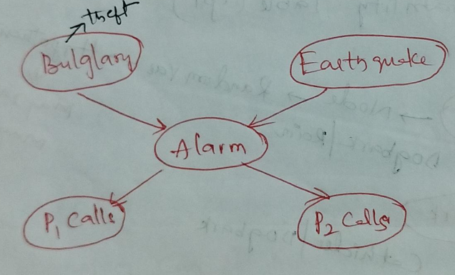
This is a very famous example.
Graph:
Burglary →
Alarm → P1_calls
Earthquake → → P2_calls

Step 1: Given Probabilities
From your notes:
$$P(B=T)=0.001 \\ P(B=F)=0.999 \\ P(E=T)=0.002 \\ P(E=F)=0.998$$

Step 2: Probability of Alarm
B | E | P(A=T)
T | T | 0.95
T | F | 0.94
F | T | 0.29
F | F | 0.001
Meaning:
- If burglary and earthquake both happen → Alarm likely.
- If neither happens → Alarm almost never rings.

Step 3: Probability of Person 1 Calling
Alarm | P(P1=T)
T | 0.90
F | 0.05

Step 4: Probability of Person 2 Calling
Alarm | P(P2=T)
T | 0.70
F | 0.01

Joint Probability Formula
For Bayesian Network:
$$P(B,E,A,P1,P2)=P(B)P(E)P(A∣B,E)P(P1∣A)P(P2∣A)$$
This is called factorization of joint probability.
Very important exam point.
Key Concept: Why Not Consider Children?
When calculating parent probability:
We do NOT consider children because of:
Conditional Independence
In Bayesian Network:
Each node is independent of non-descendants given its parents.

When No Earthquake and No Burglary
If: B = False
- E = False
Then:
$$P(A=T)=0.001$$
So alarm ringing probability is very small.
Therefore:
- P1 and P2 calling also becomes small.

tion:
Joint Probability means:
The probability that all variables happen together at the same time.
If we write:
$$P(B,E,A,P1,P2)$$
It means:
Probability that
- Burglary happens
- Earthquake happens
- Alarm rings
- Person 1 calls
- Person 2 calls
ALL together.

Why Joint Probability is Important?
Because: The entire Bayesian Network represents one big joint probability distribution.
Every smaller probability is derived from this joint probability.

Normal Way (Without Bayesian Network)
Normally, joint probability would be written as:
$$P(B,E,A,P1,P2)$$
Using chain rule:
$$=P(B)P(E∣B)P(A∣B,E)P(P1∣A,B,E)P(P2∣P1,A,B,E)$$
This is very complicated!
Too many conditional terms.

How Bayesian Network Simplifies It
Bayesian Network uses conditional independence.
From the graph:
Burglary →
Alarm → P1
Earthquake → → P2
We observe:
- Alarm depends only on B and E
- P1 depends only on Alarm
- P2 depends only on Alarm
- B and E are independent
So we simplify to: $P(B,E,A,P1,P2)=P(B)P(E)P(A∣B,E)P(P1∣A)P(P2∣A)$
This is called Factorization of Joint Probability.

MARKOV RANDOM FIELDS
Markov Random Field (MRF)
What is a Markov Random Field?
- A Markov Random Field (MRF) is a type of undirected graphical model.
- It is used in Machine Learning to represent relationships (dependencies) between random variables.
- It is especially useful in:
  - Image Processing
  - Computer Vision
  - Spatial data analysis
In simple words:
MRF shows how variables influence each other when the connections are undirected (no arrows).

Undirected Graph in MRF
- The graph has:
  - Nodes (vertices) → represent random variables
  - Edges → represent dependency between variables
Since the graph is undirected, the dependency is mutual.
Example:
If X — Y
It means X depends on Y and Y depends on X.
There is no parent/child concept like in Bayesian Networks.

Factorization in MRF
In Bayesian Networks:
- We use Conditional Probability Distributions (CPDs).
In MRF:
- We use Clique Potentials.

What is a Clique?
A clique is:
A subset of nodes where every node is connected to every other node.
In simple words:
A clique is a complete subgraph.
Example:
If we have nodes:
V = {1, 2, 3, 4}
If all are connected with each other → that is a clique.

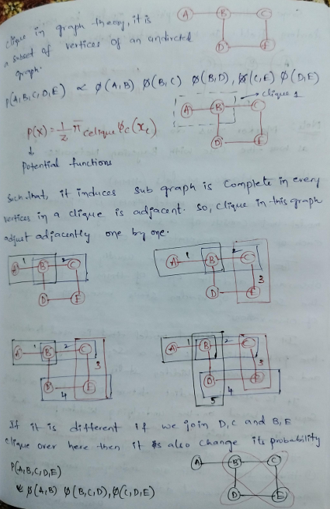
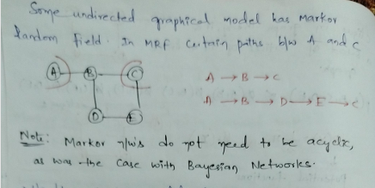
Factorization in MRF using Cliques
In MRF, the joint probability distribution is written as:
$$P(X)=\frac{1}{Z}\prod_{C∈Cliques}{ψ_{C}}(X_{C})$$
Where:
- $ψ_{C}(X_{C})$= Clique potential function
- $Z$= Normalization constant (Partition function)
$$Z=\sum_{X}{\prod_{C}{ψ_{C}}}(X_{C})$$

What is a Clique Potential?
- It is a function defined over a clique.
- It measures compatibility between variables.
- It is NOT necessarily a probability.
- It just gives a positive value.

Difference Between Bayesian Network and MRF
Bayesian Network | MRF
Directed graph | Undirected graph
Uses CPDs | Uses Clique potentials
Factorization based on parents | Factorization based on cliques
Arrows show direction | No direction

Markov Property in MRF
A node is conditionally independent of all other nodes
given its neighbors.
In simple words:
A variable only depends on its immediate neighbors, not on the entire graph.

Why MRF is Useful in Image Processing?
In images:
- Each pixel depends only on nearby pixels.
- MRF models this local dependency naturally.
Example:
If one pixel is black, nearby pixels are likely black.

First: What is a Markov Model?
A Markov Model is a model where:
The next state depends only on the current state, not on the previous history.
This is called the Markov Property.
Example:
If today is Sunny, tomorrow’s weather depends only on today (Sunny), not on what happened 3 days ago.
Also note:
✔ Markov models do not need to be acyclic (unlike Bayesian networks).
They can have loops (Sunny → Sunny).

2️⃣ What is a Hidden Markov Model (HMM)?
A Hidden Markov Model (HMM) is a probabilistic model where:
- There is a sequence of hidden states
- Each hidden state generates an observable output
- We can see the outputs
- But we cannot directly see the hidden states
👉 That’s why it is called Hidden Markov Model.
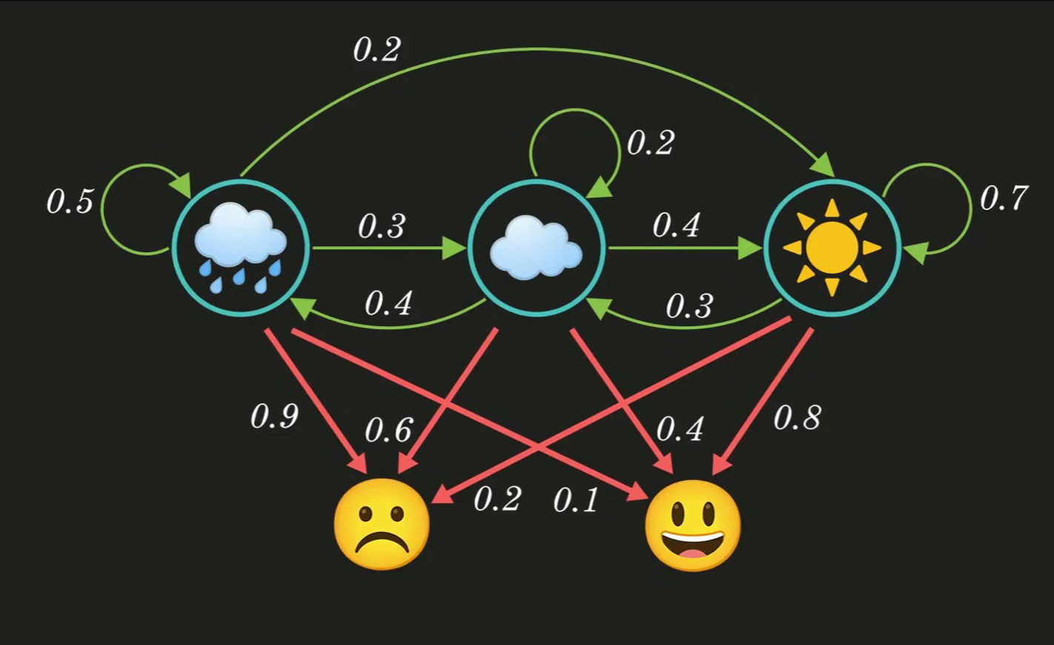

3️⃣ Simple Example from Your Notes
Hidden states (weather):
- Rainy
- Cloudy
- Sunny
We cannot directly observe the weather (in example, assume we are not there).
Observations (Jack’s mood):
- Happy
- Sad
We can call Jack and ask his mood.
👉 His mood depends on the weather.
So:
Weather (hidden) → Mood (observed)

4️⃣ Important Idea
You wrote:
HMM = Hidden Markov Chain + Observed Variables
✔ Correct.
It means:
- Hidden states follow a Markov chain.
- Each hidden state produces an observable output using probabilities.

5️⃣ Components of HMM (VERY IMPORTANT)
An HMM has 5 main components:

1) States (S)
$$S=\{S_{1},S_{2},...,S_{N}\}$$
These are hidden states.
Example:
$$S=\{Rainy,Cloudy,Sunny\}$$
The system can be in only one state at a time.

2) Observations (O)
$$O=\{o_{1},o_{2},...,o_{M}\}$$
These are observed outputs.
Example:
$$O=\{Happy,Sad\}$$

3) Transition Probabilities (A)
$$A=[a_{ij}]$$
Where:
$$a_{ij}=P(\text{next state }=S_{j}∣\text{current state }=S_{i})$$
Example from your notes:
From \ To | Rainy | Cloudy | Sunny
Rainy | 0.5 | 0.3 | 0.2
Cloudy | 0.4 | 0.2 | 0.4
Sunny | 0.0 | 0.3 | 0.7
Each row must sum to 1.
This matrix controls how weather changes.

4) Emission Probabilities (B)
$$B=[b_{j}(k)]$$
Where:
$$b_{j}(k)=P(\text{observation }o_{k}∣\text{state }S_{j})$$
Example:
State | Happy | Sad
Rainy | 0.1 | 0.9
Cloudy | 0.4 | 0.6
Sunny | 0.8 | 0.2
Meaning:
- If Sunny → 80% chance Happy
- If Rainy → 90% chance Sad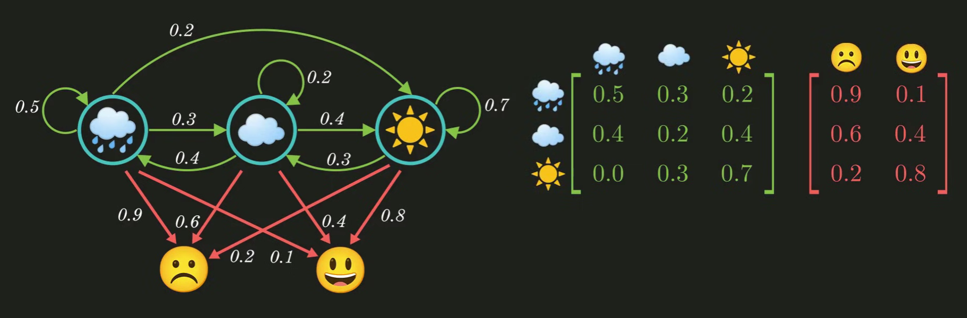
- 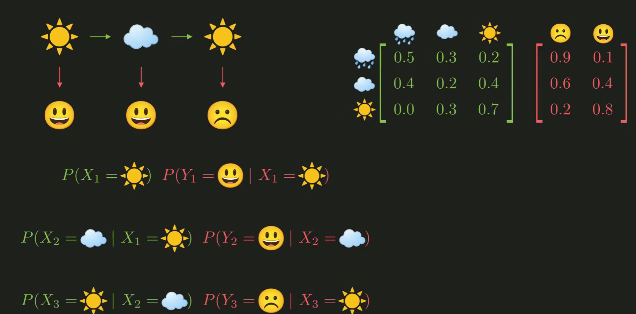
- 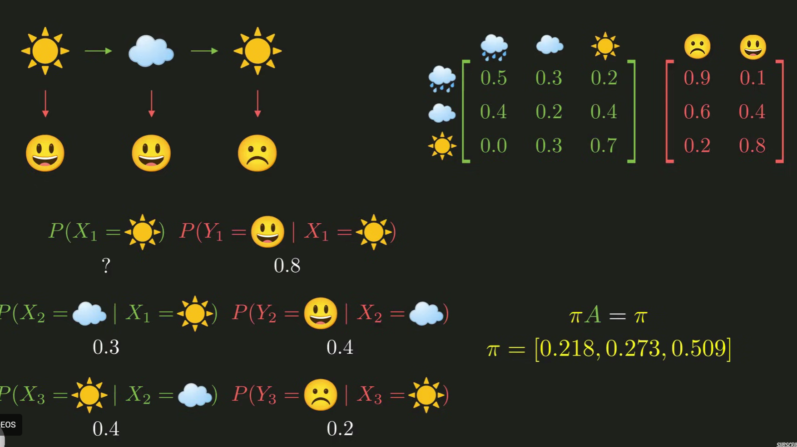

5) Initial Probabilities (π)
$$π_{i}=P(\text{starting in state }S_{i})$$
Example:
$$π=[0.6,0.4]$$
This tells us where the system starts.

6️⃣ Your Three-Day Scenario
Weather sequence:
Sunny → Cloudy → Sunny
Mood sequence:
Happy → Happy → Sad
To compute joint probability:
We multiply:
$$P(X_{1})×P(Y_{1}∣X_{1})×P(X_{2}∣X_{1})×P(Y_{2}∣X_{2})×P(X_{3}∣X_{2})×P(Y_{3}∣X_{3})$$
This works because of the Markov property.
So total probability = product of 6 terms.
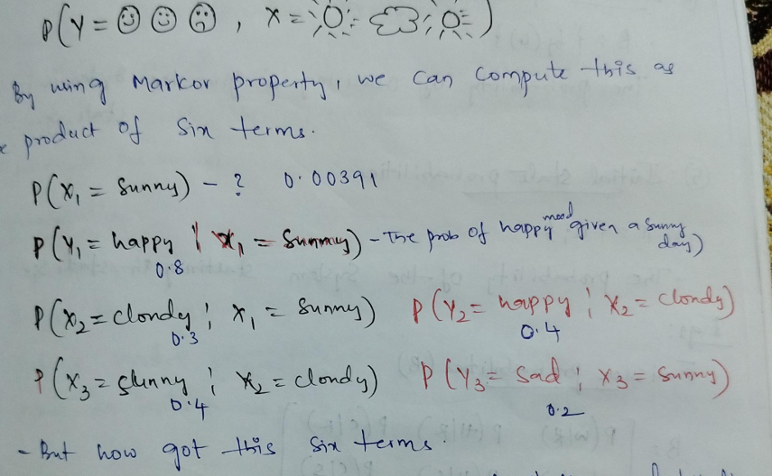

7️⃣ Very Important Assumptions in HMM
HMM makes two key assumptions:
1) Markov Assumption
Current state depends only on previous state.
$$P(X_{t}∣X_{t-1},X_{t-2},...)=P(X_{t}∣X_{t-1})$$

2) Output Independence Assumption
Observation depends only on current state.
$$P(Y_{t}∣X_{t},X_{t-1},...)=P(Y_{t}∣X_{t})$$
Mood depends only on today's weather, not yesterday’s.

8️⃣ What Problems Does HMM Solve?
HMM is used to solve 3 main problems:
1) Evaluation Problem
Given model + observations → find probability of observation sequence.
(Use Forward algorithm)

2) Decoding Problem
Given observations → find most likely hidden state sequence.
(Use Viterbi algorithm)

3) Learning Problem
Given only observations → learn A, B, π.
(Use Baum-Welch algorithm)

9️⃣ Real-Life Applications
HMM is used in:
- Speech recognition
- Handwriting recognition
- Bioinformatics (DNA sequences)
- POS tagging in NLP
- Weather prediction
- Activity recognition

🔟 Final Big Picture
Hidden Markov Model works like this:
Hidden states (weather)
⬇
Generate observations (mood)
We observe mood
We try to guess weather
So:
HMM helps us infer hidden patterns from observable data.

🔑 Short Summary (Exam Ready)
A Hidden Markov Model is a statistical model where:
- The system follows a Markov chain of hidden states.
- Each hidden state generates observable outputs.
- It is defined by (S, O, A, B, π).
- It assumes Markov property and output independence.
- It is used to infer hidden state sequences from observations.

